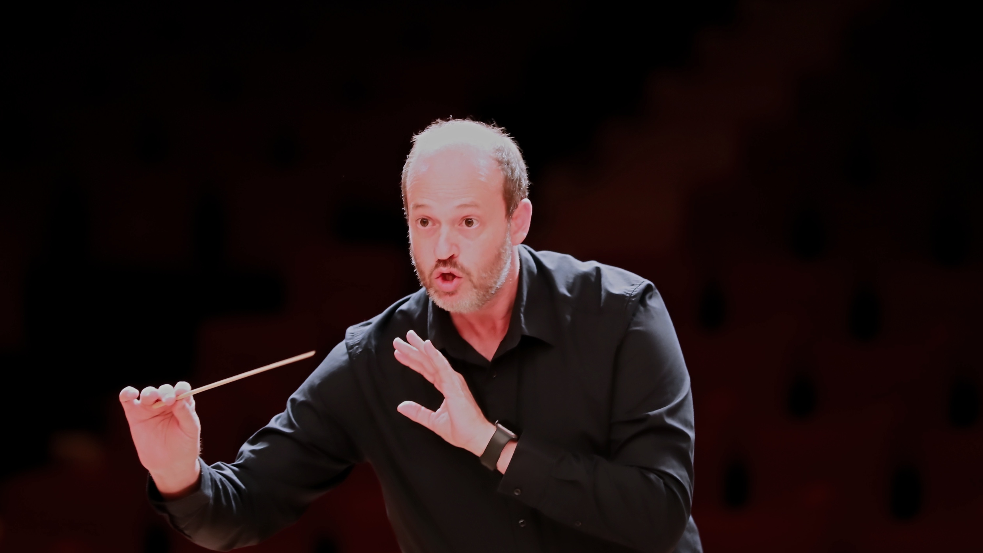
DANIELE CAMIZ
C O N D U C T O R
FULL BIO
Daniele Camiz is an Italian conductor, founder and Music Director of Orchestra ICNT and Artistic Director of I Concerti nel Tempio, a concert season established in Rome in 2014.
After studying piano with Maria Teresa Carunchio, he earned a Diploma in Piano from the G. Rossini Conservatory in Pesaro, a Diploma in Chamber Music from the Santa Cecilia Conservatory in Rome, and graduated summa cum laude in Musicology from Sapienza University of Rome. He subsequently devoted himself to orchestral conducting, training at the Escuela de Dirección Maestro Francisco Navarro Lara and earning the LRSM (Licentiate of the Royal Schools of Music) diploma from the Associated Board of the Royal Schools of Music (ABRSM), London. In 2018 he was awarded the Batuta de Bronce at the Concurso Internacional de Dirección de Orquesta 3.0.
In February 2014 he founded I Concerti nel Tempio, a concert season born almost spontaneously from the desire to bring musicians together and share music with the local community. Initially devoted to chamber music, the series gradually evolved into a reference point for orchestral repertoire, bringing together young musicians, professionals, and dedicated amateurs.
This experience led, in 2016, to the creation of Orchestra ICNT, of which he is founder and Music Director. Conceived as a project-based orchestra, ICNT brings together musicians of different backgrounds, generations, and nationalities, united by a shared commitment to the great symphonic repertoire. The ensemble’s work is rooted in collaboration, attentive listening, and the collective shaping of orchestral sound, combining artistic rigour with enthusiasm and mutual trust.
This artistic vision finds its fullest expression in the Mozart Symphonies Challenge, a project dedicated to the complete symphonic works of Wolfgang Amadeus Mozart. Each event brings together study, an open rehearsal, live streaming, and the concert itself within a single day, allowing audiences to experience not only the final performance but also the creative process through which the interpretation takes shape. The project has become an original model of musical outreach and orchestral work, inviting listeners to become active witnesses to the making of a performance.
Alongside his orchestral activity, since 2015 he has been Music Director of Coro Raro, an independent vocal ensemble devoted primarily to the a cappella repertoire and to vocal music from a variety of traditions.
He also collaborates regularly with pianist Marcella Crudeli on the Magisterium project for young pianists. In this context, he takes part in the selection and evaluation of soloists, contributes to the artistic planning of each edition, and conducts the orchestral performances, offering outstanding young musicians the opportunity to perform major concerto repertoire in a professional concert setting.
Over the course of his career, he has conducted 81 concerts, performing 198 works by 59 composers, with a particular focus on the European symphonic repertoire from the Classical and Romantic periods. Among his most significant achievements is the Mozart Symphonies Challenge, through which he has already conducted 48 of Mozart’s 50 symphonies as part of a complete exploration of the composer’s symphonic output.
At the heart of his work lies the conviction that the quality of an orchestra grows from attentive listening, shared responsibility, and the ability to transform the study of a score into an authentic musical experience. Rather than pursuing technical perfection as an end in itself, he seeks to build a living orchestral language capable of engaging musicians and audiences alike in the same journey of discovery.

