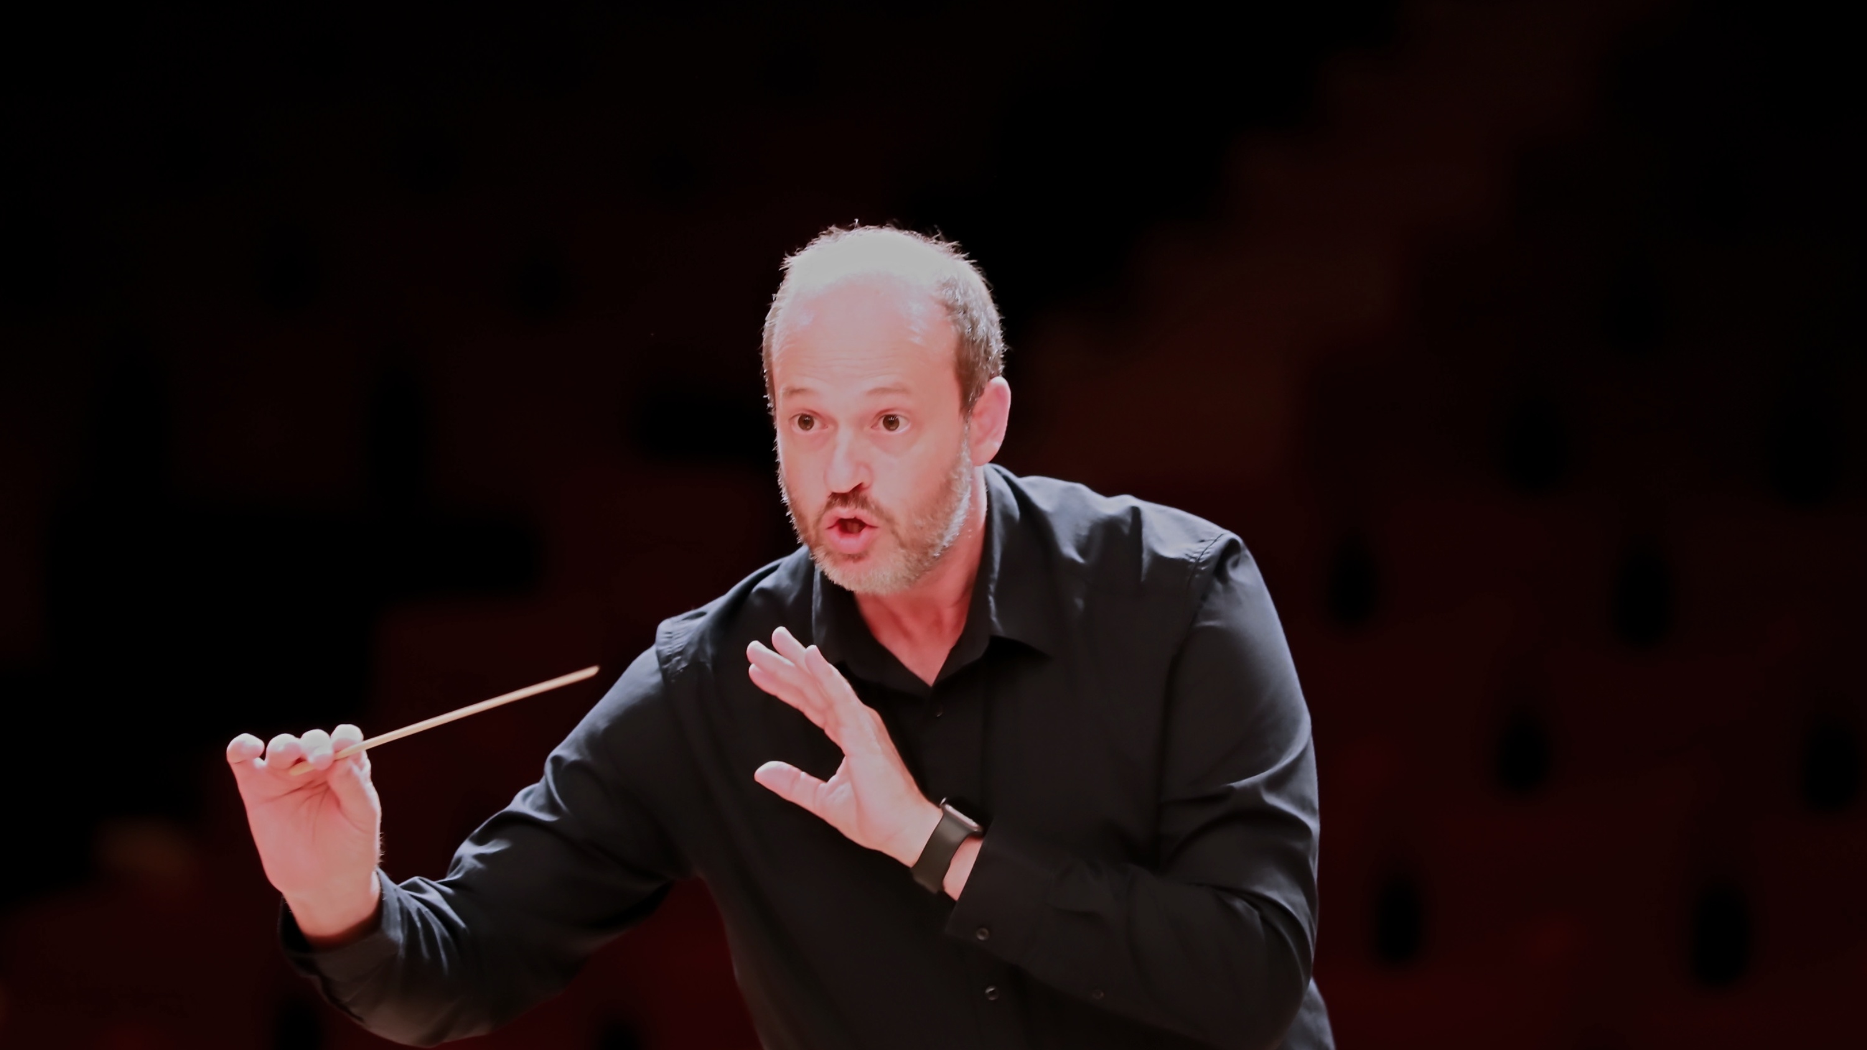
DANIELE CAMIZ
C O N D U C T O R
MEDIUM BIO
Daniele Camiz is an Italian conductor, founder and Music Director of Orchestra ICNT and Artistic Director of I Concerti nel Tempio, a concert season based in Rome since 2014.
His work is devoted primarily to the great European symphonic repertoire, with a particular focus on Mozart, Beethoven, and the Classical and Romantic traditions.
After completing his studies in piano and musicology, he trained in orchestral conducting at the Escuela de Dirección Maestro Francisco Navarro Lara, later earning the LRSM (Licentiate of the Royal Schools of Music) diploma from the Associated Board of the Royal Schools of Music (ABRSM), London. In 2018 he was awarded the Batuta de Bronce at the Concurso Internacional de Dirección de Orquesta 3.0.
Since 2016 he has developed an extensive concert activity with Orchestra ICNT, creating a number of artistic projects. Among them, the Mozart Symphonies Challenge, devoted to the complete symphonic works of Wolfgang Amadeus Mozart, presents an original format in which an open rehearsal, live streaming, and concert all take place on the same day, allowing audiences to experience not only the final performance but also the process through which the interpretation is shaped.
He also collaborates regularly with pianist Marcella Crudeli on the Magisterium project for young pianists, taking part in the selection and evaluation of soloists, the artistic planning of each edition, and conducting the orchestral performances. Alongside his orchestral work, he has served as Music Director of Coro Raro, an independent vocal ensemble devoted primarily to the a cappella repertoire, since 2015.
At the heart of his work lies the belief that orchestral music reaches its fullest expression through attentive listening, the collective shaping of sound, and the shared journey of discovery between musicians and audiences.

