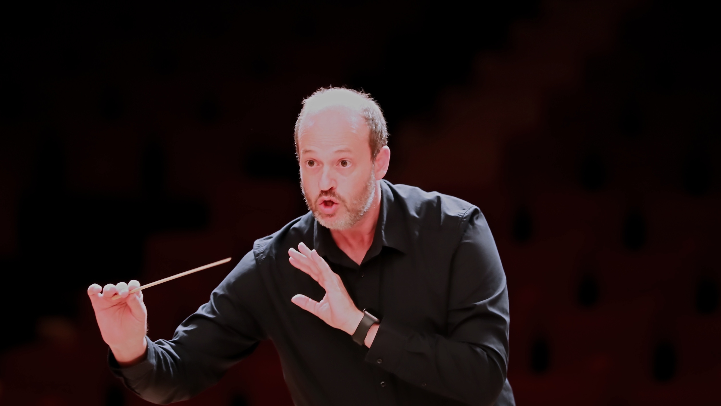
DANIELE CAMIZ
C O N D U C T O R
SHORT BIO
Daniele Camiz is an Italian conductor. His work is devoted to the great European symphonic repertoire and to developing artistic projects centred on orchestral listening, the growth of musicians, and the sharing of the creative process with audiences. He is the founder and Music Director of Orchestra ICNT, Artistic Director of the concert season I Concerti nel Tempio, and creator of the Mozart Symphonies Challenge.

