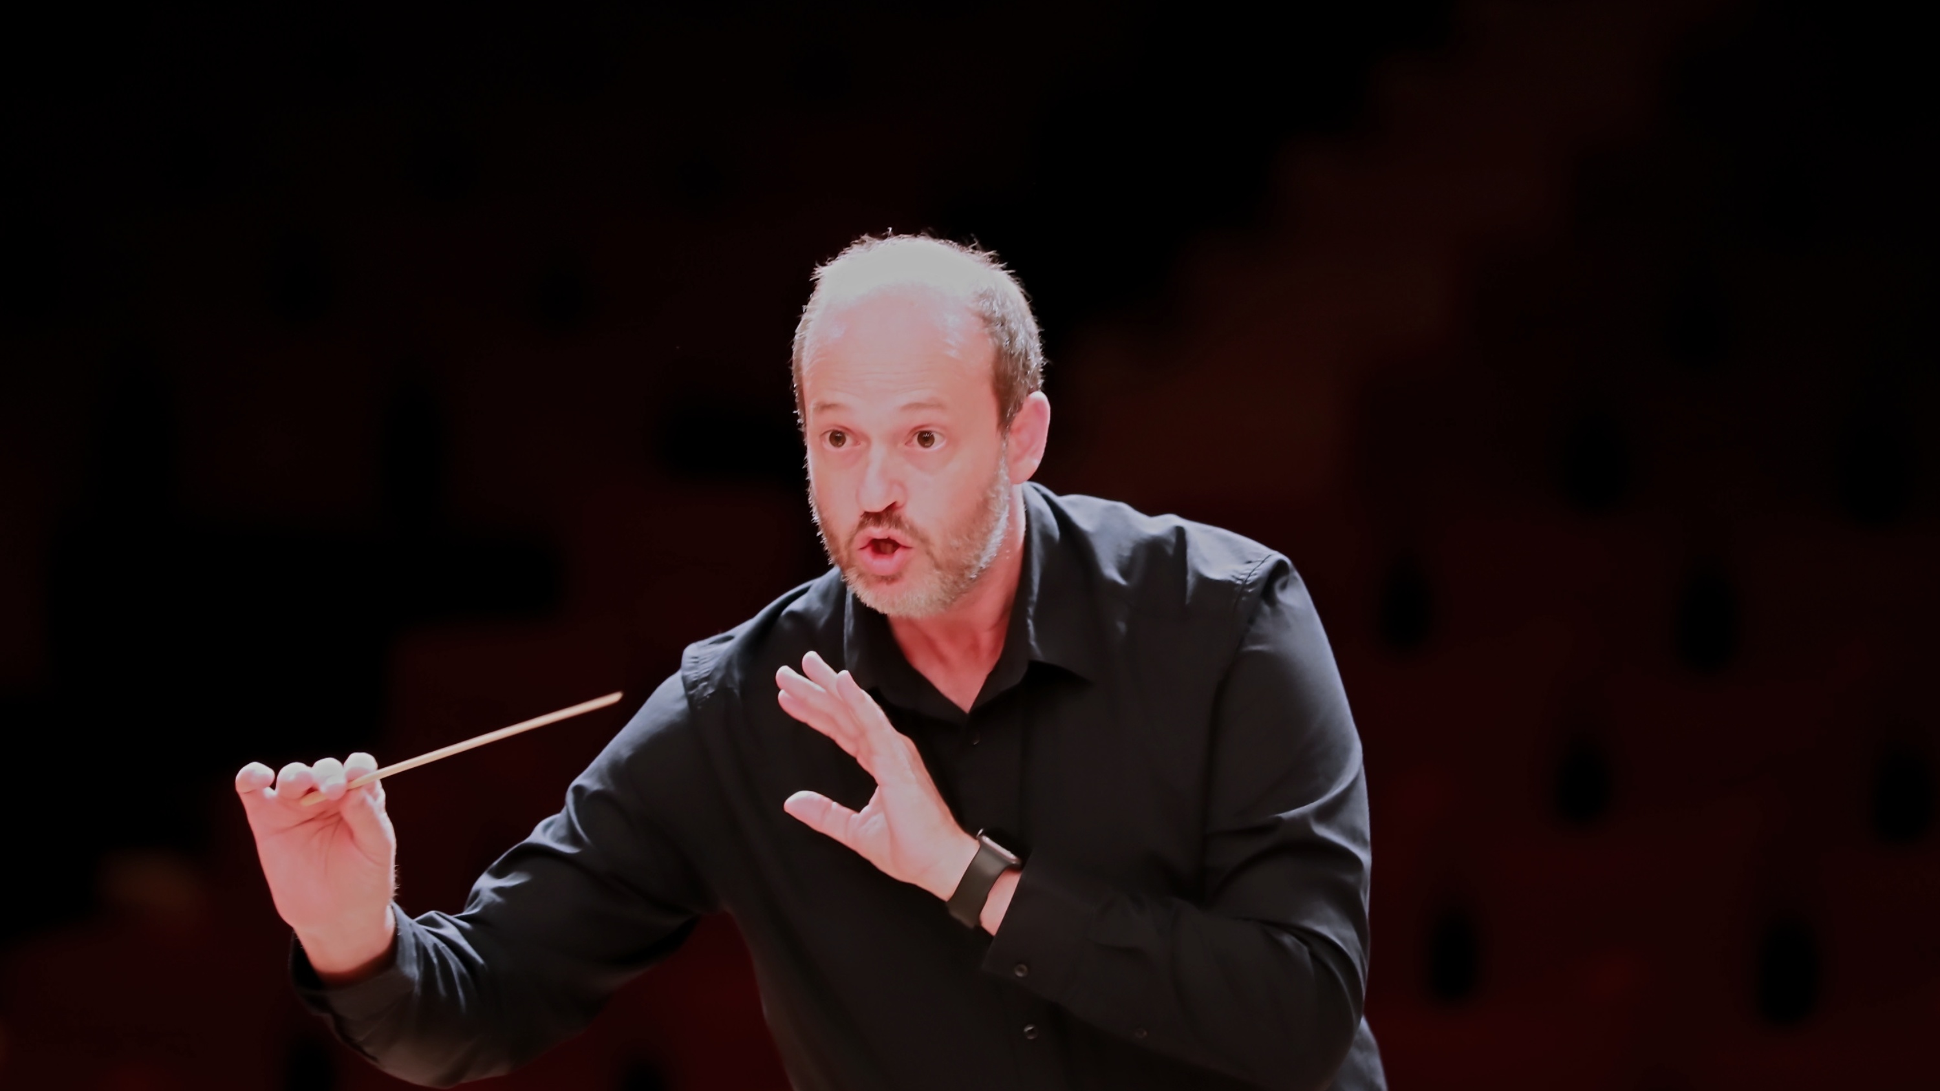
DANIELE CAMIZ
C O N D U C T O R
ARTISTIC PROFILE

PROFILE
Nationality: Italian
Based in: Rome, Italy
Profession: Conductor

ARTISTIC ACTIVITY & PROJECTS

I Concerti nel Tempio (since 2014)
Founder and Artistic Director of I Concerti nel Tempio, a concert season established in 2014 at the Waldensian Church of Piazza Cavour in Rome. Initially devoted primarily to chamber music, the series gradually evolved into a platform dedicated to the great orchestral repertoire.

Coro Raro (since 2015)
Music Director of Coro Raro, an independent vocal ensemble devoted primarily to the a cappella repertoire and vocal music from a variety of traditions.

Orchestra ICNT (since 2016)
Founder and Music Director of Orchestra ICNT, a project-based orchestra bringing together young musicians, professionals, students and dedicated amateurs, encouraging collaboration across generations, educational backgrounds and nationalities through the performance of the great symphonic repertoire.

Mozart Symphonies Challenge (2019–2026)
Creator and Music Director of the Mozart Symphonies Challenge, a project dedicated to the complete symphonic works of Wolfgang Amadeus Mozart. Each event combines score preparation, an open rehearsal, live streaming and the public performance within a single day, allowing audiences to experience the development of the musical interpretation from rehearsal to concert.

ARTISTIC ACTIVITY & PROJECTS · CONTINUED

Magisterium
Regular collaborator with pianist Marcella Crudeli in the Magisterium project for young pianists. In addition to conducting the orchestra, he takes part in the selection and evaluation of soloists and in the artistic planning of each edition, offering outstanding students the opportunity to perform the concerto repertoire with orchestra in a public concert setting.

ARTISTIC ACTIVITY
- 81 concerts conducted
- 198 works in repertoire
- 241 public performances
- 59 composers performed
- 63 complete symphonies conducted
  - 48 by Wolfgang Amadeus Mozart
  - 15 by other composers
- 74 collaborating soloists
- 69 concerts with Orchestra ICNT
- 59 concerts at the Waldensian Church of Piazza Cavour (Rome)

EDUCATION
- LRSM (Licentiate of the Royal Schools of Music) in Orchestral Conducting — Associated Board of the Royal Schools of Music (ABRSM), London
- Orchestral Conducting studies at the Escuela de Dirección Maestro Francisco Navarro Lara
- Master’s Degree (summa cum laude) in Musicology — Sapienza University of Rome
- Diploma in Chamber Music — Conservatory of Music “Santa Cecilia”, Rome
- Diploma in Piano — Conservatory of Music “G. Rossini”, Pesaro

AWARD
- Batuta de Bronce — Concurso Internacional de Dirección de Orquesta 3.0 (2018)

REPERTOIRE
Predominantly European symphonic repertoire, spanning the Classical period to the early twentieth century, with particular emphasis on Mozart, Beethoven, Mendelssohn, Brahms, Schumann and Dvořák.
The repertoire includes symphonies, concertos for solo instrument and orchestra, overtures, orchestral suites, symphonic poems, vocal works and chamber ensemble repertoire.
For a detailed repertoire list and updated statistics, see the accompanying Repertoire document.

INTERNATIONAL ACTIVITY
Throughout his career, he has collaborated with orchestras and ensembles in Italy and abroad, developing concert and educational projects across Europe, South America and Asia.

WEBSITE
www.danielecamiz.com

