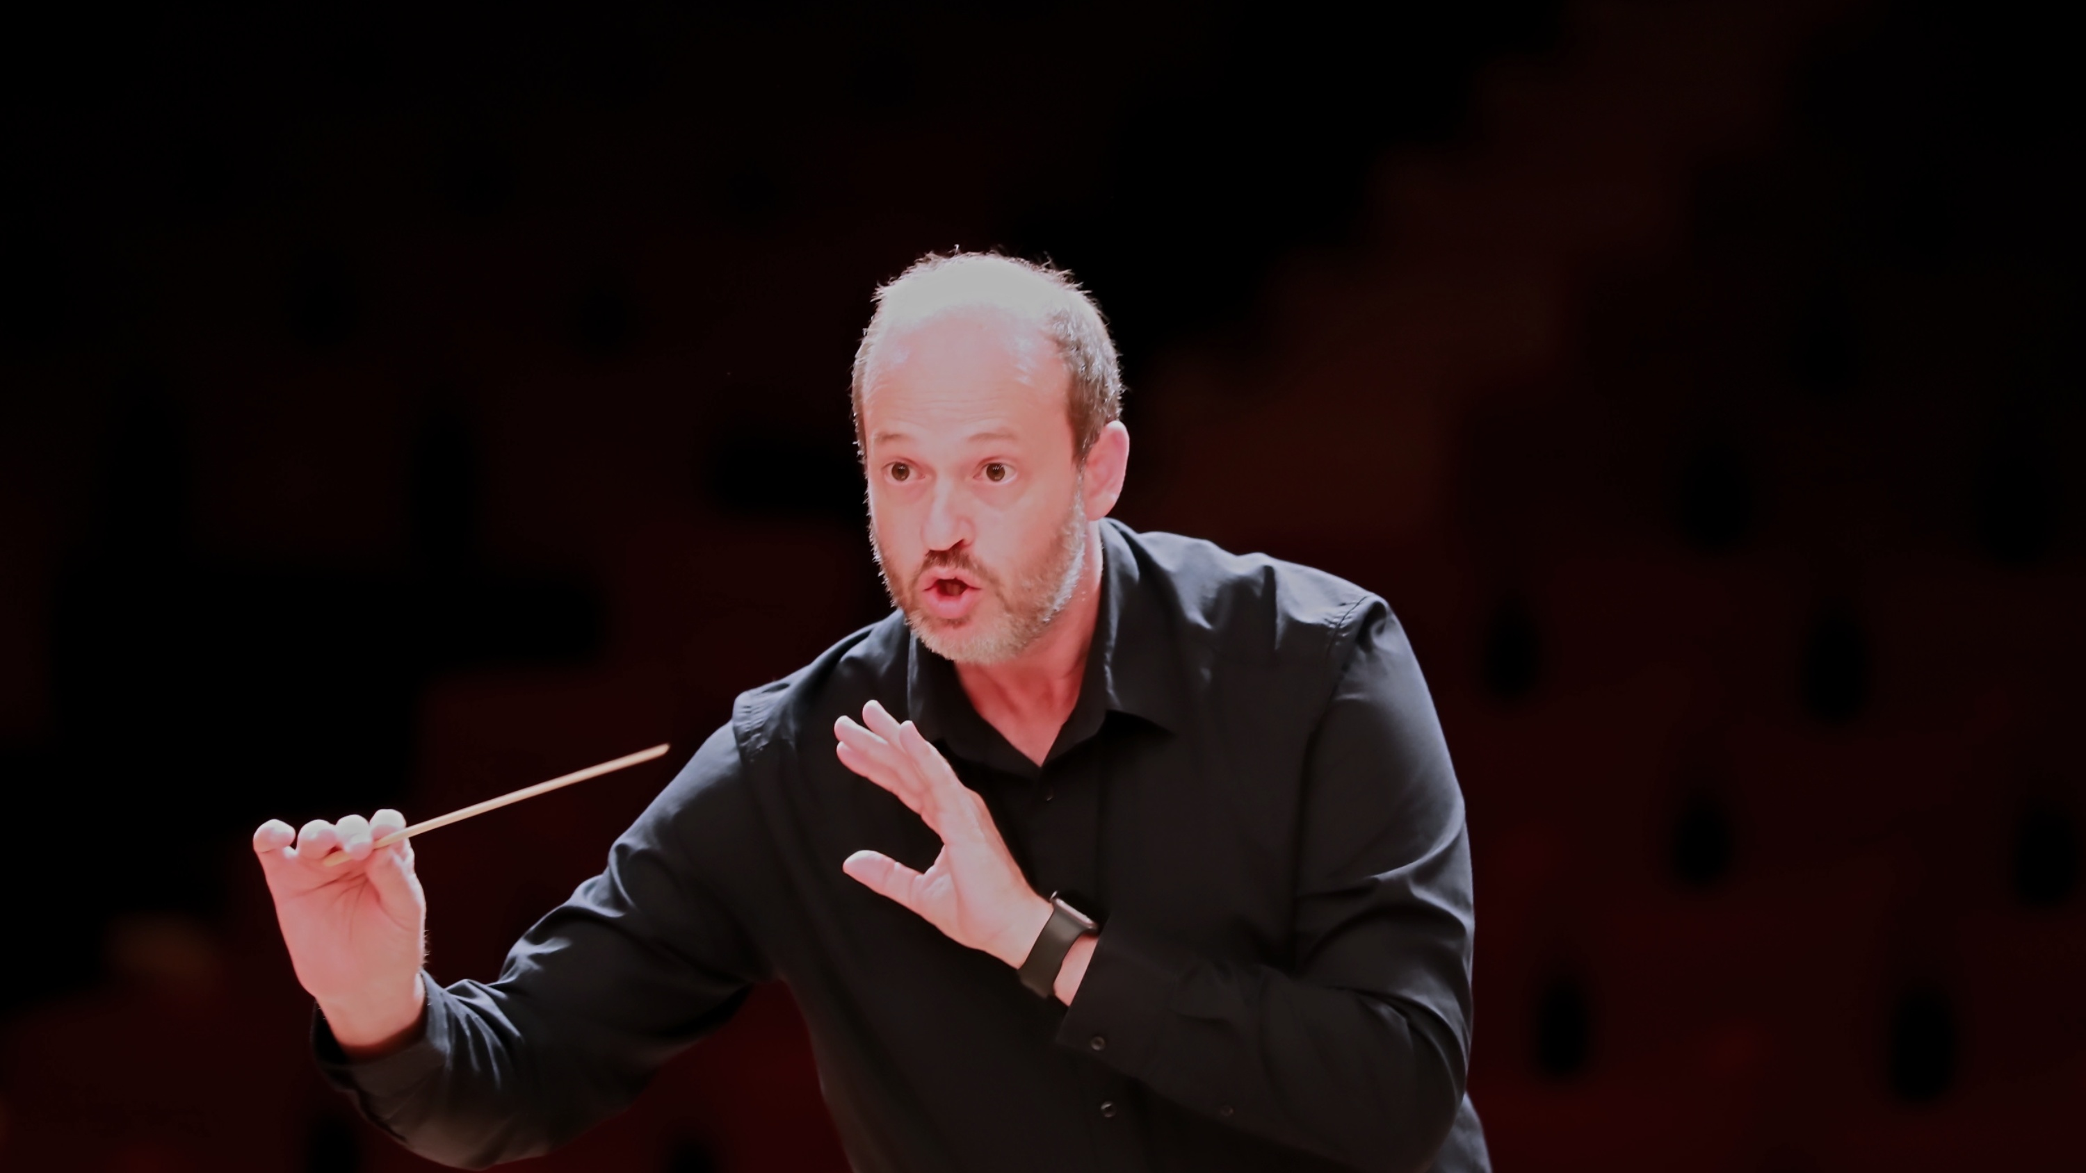
DANIELE CAMIZ
C O N D U C T O R
PROFILE
Daniele Camiz is an Italian conductor.
Conducting entered his professional life relatively late, yet it has been part of the way he has experienced music since childhood. Long before learning its technique, listening meant following the gesture, imagining its movement and searching for a way to make musical expression visible.
His work is rooted in a simple conviction: an orchestra truly begins to make music when it stops merely playing together and starts listening to itself. This is where phrasing, character, colour, contrast and the full range of musical expression emerge. A successful rehearsal is not necessarily one in which everything is perfect, but one in which time seems to pass too quickly and the musicians finish the day physically tired yet full of energy and enthusiasm, having discovered something new in the music and in the way they create it together.
In February 2014, together with his wife, he founded I Concerti nel Tempio, a concert season that began almost spontaneously from the desire to bring musician friends together and share music with the local community. The first concerts, devoted to chamber music, were played on a hired piano by musicians taking part voluntarily — as the orchestra and the conductor still do today. The concerts have always been free of charge; the offerings collected go not to the performers but to the instruments: first towards buying that piano, which thus became a permanent instrument of the Waldensian Church of Piazza Cavour in Rome, then towards restoring the organ, and today towards the fund for their upkeep. Over the years the season grew steadily, and an increasing number of young musicians chose this space for their first public performances.
In 2016, while pursuing his conducting studies, Orchestra ICNT came into being just as naturally. What began as a single Easter Monday concert with a small string orchestra gradually developed into a permanent artistic project and, in the years that followed, became the core of the concert season. After the pandemic, the activity of I Concerti nel Tempio became almost entirely devoted to orchestral repertoire.
Orchestra ICNT still preserves the spirit in which it was founded: a project-based orchestra bringing together musicians of different ages, backgrounds and levels of experience, united by the desire to approach the great symphonic repertoire with commitment and seriousness. Rehearsals take place in an atmosphere that is both demanding and relaxed, where individual responsibility, attentive listening and mutual trust encourage the ensemble to grow and gradually achieve greater musical independence.
This vision finds its fullest expression in the Mozart Symphonies Challenge, a project devoted to the complete symphonies of Wolfgang Amadeus Mozart. Inspired by his studies with Francisco Navarro Lara and by the desire to explore systematically a repertoire rarely performed as a complete cycle, each event brings together preparation, rehearsal and performance within a single day. The rehearsal is open to the public and live-streamed: mistakes, decisions and solutions are never concealed, because the creative process itself is considered an essential part of the musical experience.
The Challenge has gradually shaped a way of working based on rapid musical thinking, constant listening and the ability to identify what truly matters in a score. Limited rehearsal time is not regarded as a constraint but as an incentive to study more deeply, define priorities with clarity and make the most of every musician’s contribution.
In Mozart’s music he seeks above all freshness, transparency and a strong sense of theatre. Rather than an abstract ideal of perfection, he finds in these works a continuous representation of human emotions, their contrasts and their sudden changes. Fidelity to the score is therefore understood not as a limitation on interpretative freedom but as the starting point for a deeper understanding of its meaning.
Alongside his orchestral activity he has served since 2015 as Music Director of Coro Raro, an independent vocal ensemble devoted primarily to a cappella repertoire and vocal music from a variety of traditions.
His background in musicology forms an essential part of his artistic identity. The study of sources, historical context and performance practice provides the tools through which he seeks to restore freshness, clarity and communicative power to the music, without allowing it to become a museum object.
At the heart of his work remains a conviction that has grown stronger over the years: music is born through the encounter between people. Technique, study and discipline are indispensable, but they acquire their true meaning only when they enable a group of musicians to listen to one another, breathe together and communicate with authenticity to their audience.

