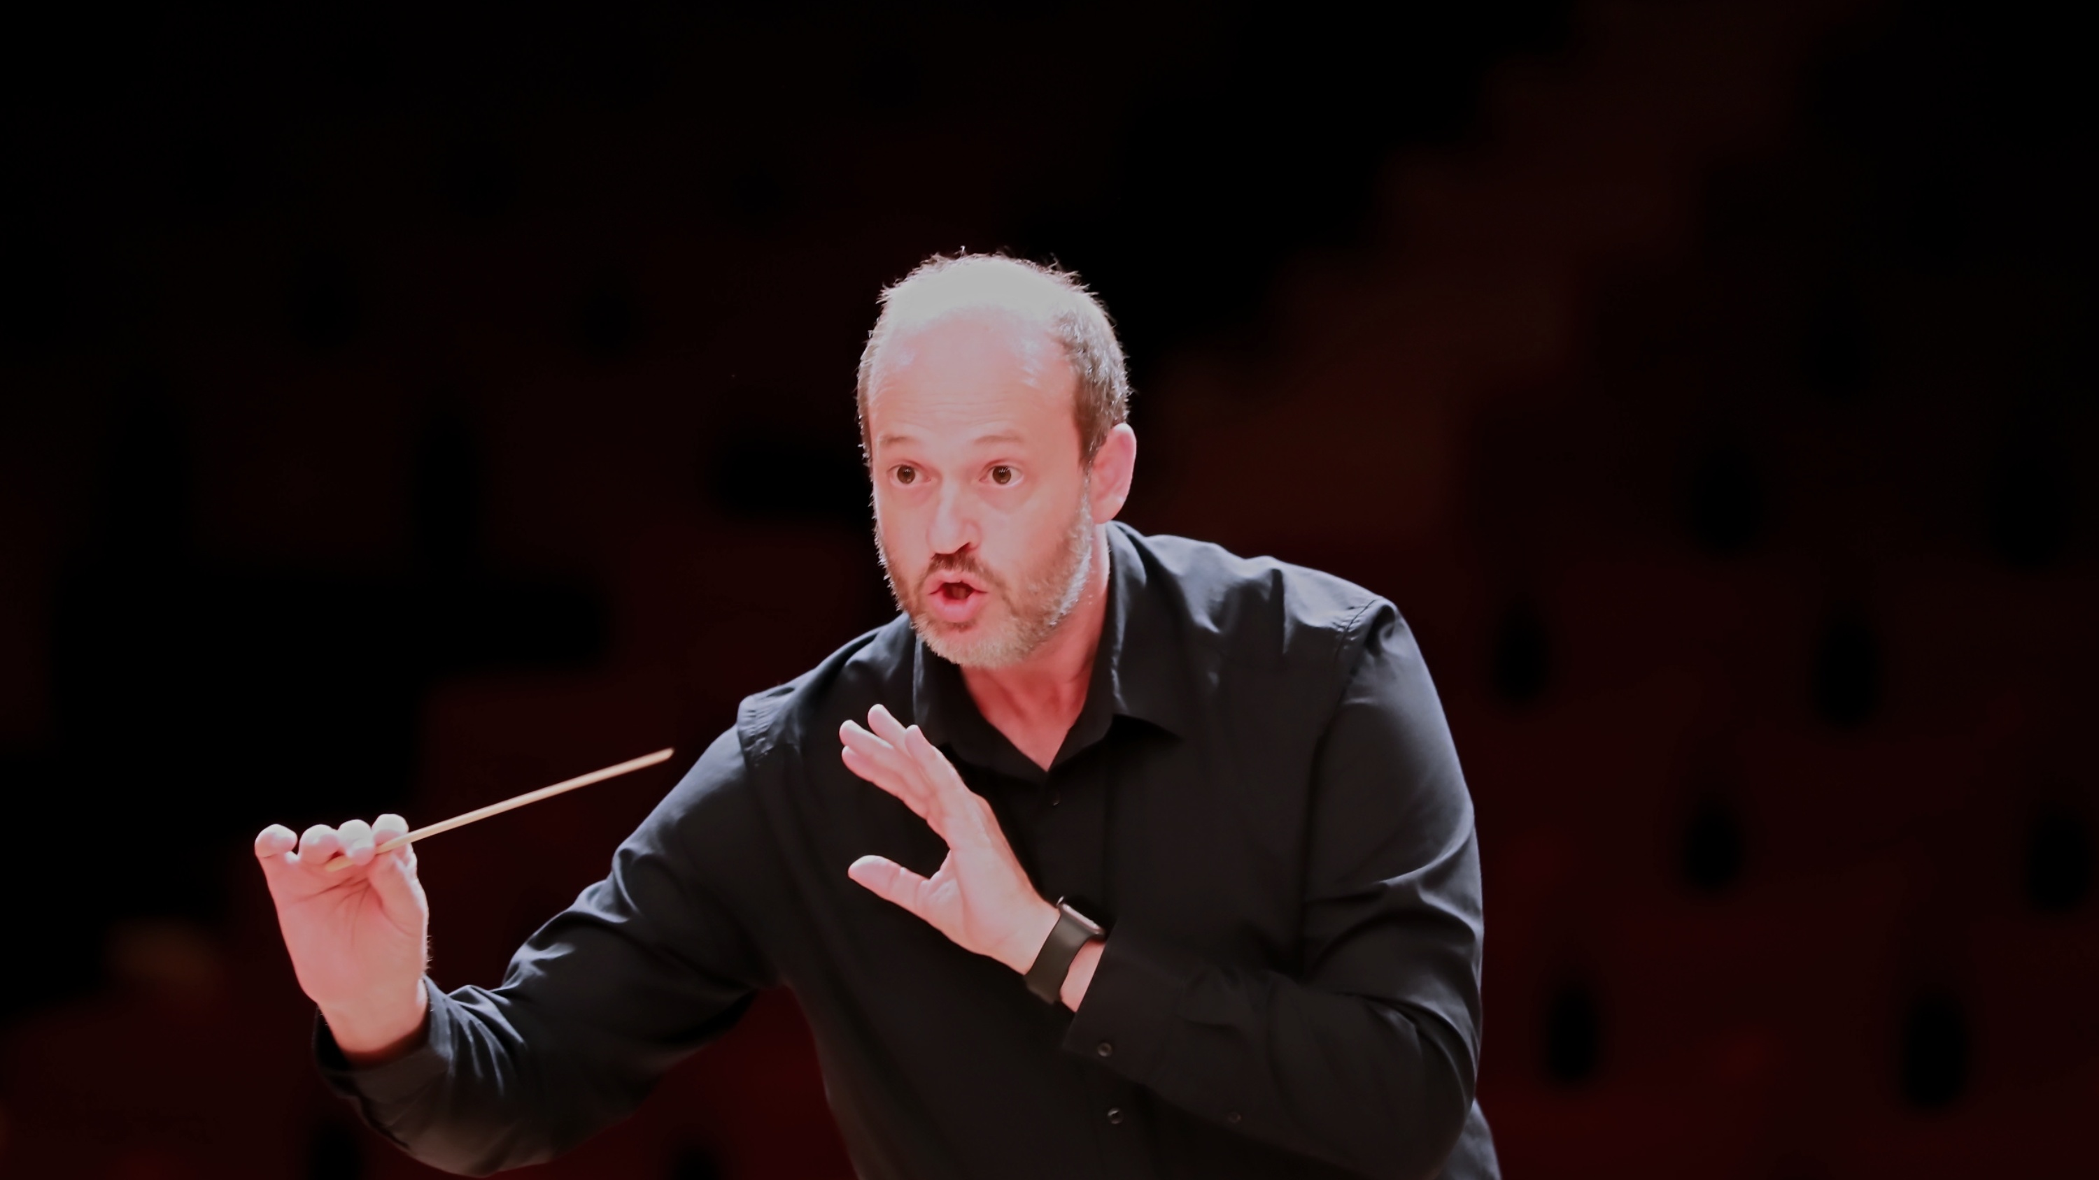
DANIELE CAMIZ
C O N D U C T O R
CONDUCTING REPERTOIRE

ARTISTIC PROJECTS

Mozart Symphonies Challenge
48 of Mozart’s 50 symphonies have been performed as part of the Mozart Symphonies Challenge (2019–2026). Completion of the complete cycle is scheduled for December 2026.

Magisterium
Ongoing collaboration with pianist Marcella Crudeli dedicated to the artistic development of young pianists. To date, the project comprises: 7 editions; 21 young soloists; 15 different piano concertos.

SYMPHONIES

Wolfgang Amadeus Mozart
48 complete symphonies

OTHER COMPLETE SYMPHONIES

Ludwig van Beethoven
- Symphony No. 2 in D major, Op. 36
- Symphony No. 5 in C minor, Op. 67

Johannes Brahms
- Symphony No. 4 in E minor, Op. 98

Benjamin Britten
- Simple Symphony, Op. 4

Antonín Dvořák
- Symphony No. 9 in E minor, Op. 95 From the New World

Franz Joseph Haydn
- Symphony No. 101 in D major, Hob. I:101 The Clock

Felix Mendelssohn Bartholdy
- String Symphony No. 7 in D minor, MWV N 7
- Symphony No. 3 in A minor, Op. 56 Scottish
- Symphony No. 4 in A major, Op. 90 Italian
- Symphony No. 5 in D major, Op. 107 Reformation

Sergei Prokofiev
- Symphony No. 1 in D major, Op. 25 Classical

Joachim Raff
- Sinfonietta for Wind Instruments, Op. 188

Franz Schubert
- Symphony in B minor, D.759 Unfinished

Robert Schumann
- Symphony No. 4 in D minor, Op. 120

Pyotr Ilyich Tchaikovsky
- Symphony No. 6 in B minor, Op. 74 Pathétique

CONCERTOS

PIANO

Ludwig van Beethoven
- Piano Concerto No. 1, Op. 15
- Piano Concerto No. 2, Op. 19
- Piano Concerto No. 3, Op. 37
- Piano Concerto No. 5 in E-flat major, Op. 73 Emperor

Marco Enrico Bossi
- Organ Concerto, Op. 100

Frédéric Chopin
- Piano Concerto No. 1 in E minor, Op. 11
- Piano Concerto No. 2 in F minor, Op. 21

George Gershwin
- Rhapsody in Blue

Edvard Grieg
- Piano Concerto in A minor, Op. 16

Franz Joseph Haydn
- Keyboard Concerto in D major, Hob. XVIII:11 (performed in two movements)

Felix Mendelssohn Bartholdy
- Piano Concerto No. 1 in G minor, Op. 25

Wolfgang Amadeus Mozart
- Piano Concerto No. 12 in A major, K.414
- Piano Concerto No. 20 in D minor, K.466
- Piano Concerto No. 23 in A major, K.488

Giovanni Paisiello
- Piano Concerto No. 2 in C major

Robert Schumann
- Piano Concerto in A minor, Op. 54 (one movement)

Pyotr Ilyich Tchaikovsky
- Piano Concerto No. 1 in B-flat minor, Op. 23 (first movement)

VIOLIN
- Johann Sebastian Bach — Violin Concerto in A minor, BWV 1041
- Johannes Brahms — Violin Concerto in D major, Op. 77
- Felix Mendelssohn Bartholdy — Violin Concerto in E minor, Op. 64
- Jean Sibelius — Violin Concerto in D minor, Op. 47

VIOLONCELLO
- Robert Schumann — Cello Concerto in A minor, Op. 129
- Pyotr Ilyich Tchaikovsky — Variations on a Rococo Theme, Op. 33

OTHER SOLO INSTRUMENTS
- Luigi Cherubini — Horn Sonata No. 1
- Alexander Glazunov — Concerto for Alto Saxophone and String Orchestra, Op. 109
- Wolfgang Amadeus Mozart — Horn Concerto No. 1, K.412
- Wolfgang Amadeus Mozart — Concerto for Flute and Harp, K.299 (second movement)

OVERTURES AND OPERA SINFONIAS

Wolfgang Amadeus Mozart
- Die Entführung aus dem Serail
- Idomeneo
- Der Schauspieldirektor
- Le nozze di Figaro
- Don Giovanni
- Die Zauberflöte
- La clemenza di Tito

Felix Mendelssohn Bartholdy
- The Hebrides
- The Fair Melusine
- A Midsummer Night’s Dream

Fanny Mendelssohn
- Overture in C major, H.265

Ludwig van Beethoven
- Coriolan, Op. 62
- Egmont, Op. 84
- The Consecration of the House, Op. 124

Johannes Brahms
- Academic Festival Overture, Op. 80
- Tragic Overture, Op. 81

Franz Schubert
- Overture in the Italian Style D.590
- Overture in the Italian Style D.591

Gioachino Rossini
- L’italiana in Algeri
- La gazza ladra

Giuseppe Verdi
- Nabucco
- I vespri siciliani
- La forza del destino

Vincenzo Bellini
- Sinfonia in G minor

Carl Maria von Weber
- Der Freischütz

Pyotr Ilyich Tchaikovsky
- Romeo and Juliet

SACRED MUSIC

Wolfgang Amadeus Mozart
- Exsultate, jubilate, K.165
- Mass in C major, K.257
- Coronation Mass, K.317

SUITES
- Johann Sebastian Bach — Orchestral Suite No. 3, BWV 1068
- Edvard Grieg — Peer Gynt, Suite No. 1, Op. 46
- Edvard Grieg — From Holberg’s Time, Op. 40
- George Frideric Handel — Suite No. 3, HWV 350
- Carl Nielsen — Little Suite, Op. 1
- Ottorino Respighi — Ancient Airs and Dances, Suite No. 3
- Peter Warlock — Capriol Suite

OTHER ORCHESTRAL WORKS
- Samuel Barber — Adagio for Strings, Op. 11
- Johannes Brahms — Hungarian Dances Nos. 1, 3 & 5
- Gaetano Donizetti — Wind Sinfonia, A.509
- Antonín Dvořák — Scherzo capriccioso, Op. 66
- Edward Elgar — Serenade for Strings, Op. 20
- Edvard Grieg — Norwegian Dances, Op. 35
- Vasily Kalinnikov — Serenade
- Nikolai Rimsky-Korsakov — Capriccio espagnol, Op. 34
- Franz Schubert — Rondo, D.438
- Bedřich Smetana — Má vlast: Vltava
- Johann Strauss II — An der schönen blauen Donau, Wein, Weib und Gesang, Ägyptischer Marsch
- Pyotr Ilyich Tchaikovsky — Capriccio italien, Op. 45

VOCAL REPERTOIRE
Opera arias, sacred works and concert repertoire by
- Bellini
- Delibes
- Donizetti
- Dvořák
- Fanny Mendelssohn
- Mascagni
- Mozart
- Puccini
- Rossini
- Verdi
as well as Italian songs, Neapolitan songs and Korean art songs.

